Vision Brainstorming
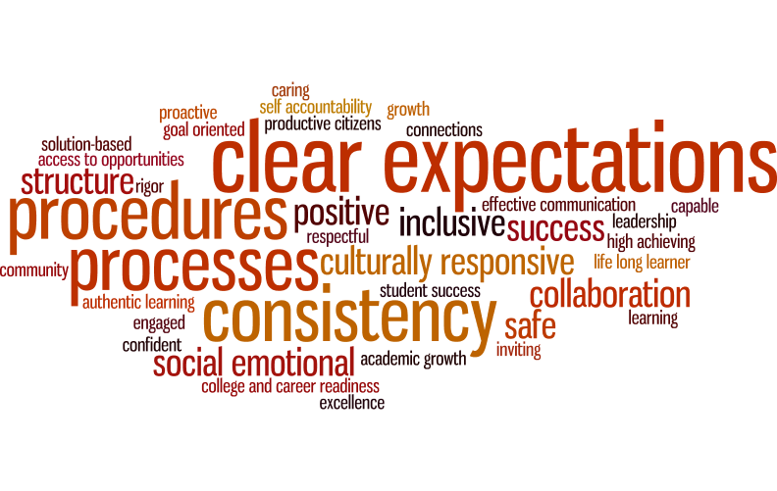

Vison Statements
- Respectful, productive, and successful citizens
- Providing scholars with a holistic education that will further improve their quality and value of life.
- Respectful, learning community where students and adults have an eagerness to learn, which will lead students to college and career readiness and productive citizenship.
- As a model school, JEMMMP, will lead and empower students, community, and others to produce future leaders and organized success.
- 100% active, eager, engaged, and self-motivated learners
- A nationally recognized institution of academic excellence, empowering all to become lifelong learners and critical thinkers
- A nationally recognized institution of academic excellence, propelling teaching and learning for all
- A positive, high achieving, safe, culturally responsive, learning environment

Mission Statements
- To provide a safe environment where educators plan collaboratively to provide data driven instruction….
- To be a collaborative environment filled with strong leaders where all stakeholders have a voice and help to provide services and opportunities for success to all.
- To empower students with academic, social-emotional, and lifelong learning skills to help ensure a healthy and prosperous future
- Strive to teach and engage students in meaningful, lasting instruction provided by a well formed educational team
- To lead a pathway to success through high-achieving, positive, collaborative experiences in a safe, productive environment
- To provide a safe, caring respectful environment where there is consistent, clear communication among all stakeholders to develop lifelong learners
- To be a safe community where all scholars are provided with social emotional support so they can experience real-world, authentic learning from a caring faculty that prepares scholars to be globally competitive.
- Develop a positive culture of student achievement through lifelong learning and community involvement.

