Our purpose is to foster a culture of collaboration to support student success.

Outcomes:
- Identify successful practices throughout the department.
- Identify barriers for students achieving at high levels based on the areas of focus for this year.
- Begin developing logic models to serve as a road map to inform future work.
- Identify next steps.
- Reflect upon our learning.
- Provide feedback about the work.

Inter-VENN-tion
- Individually, what are your hopes, fears, successes, and goals for your role in exceptional education?
- Share in pairs.
- Whole Group Share
Fears | Hopes | Successes
- disseminating wrong information  - time constraints  - being spread too thin  - never building capacity because not at schools  - the multiple initiatives and information sources  - overwhelmed schools and teachers  - as district grows, the need grows—how will the needs be handled? | - impact student success  - empowering and supporting families and teachers  - building capacity—empowering others; ownership of information; “teach them to fish”  - teacher relationships so feedback can occur  - improved data collection  - culture of collaboration | - empowering others and growing leaders  - expertise being shared with others  - coaching to improve practice (modeling, feedback, etc.)  - building relationships—trust  - smooth transition to new tier  - has workspace  - building teacher understanding

How do we spread these successes throughout all MNPS classrooms?
Shift the Narrative: ”From ‘fixing the teacher’ to collaborative expertise” (Hattie, 2015)
Hattie, J. (Fall 2015). What works in education: The politics of collaborative expertise. London, UK: Pearson. Retrieved from https://www.pearson.com/content/dam/corporate/global/pearson-dot-com/files/hattie/150526_ExpertiseWEB_V1.pdf

Here’s a link to other John Hattie books and resources: https://visible-learning.org/category/books/

Fishbone Analysis
Areas of Focus for 2017-2018
- Data- Based Decision Making
- Instructionally Appropriate IEP’s
- Access to High Quality Core Instruction
- Effective Intensive Interventions

Gallery Walk for Feedback
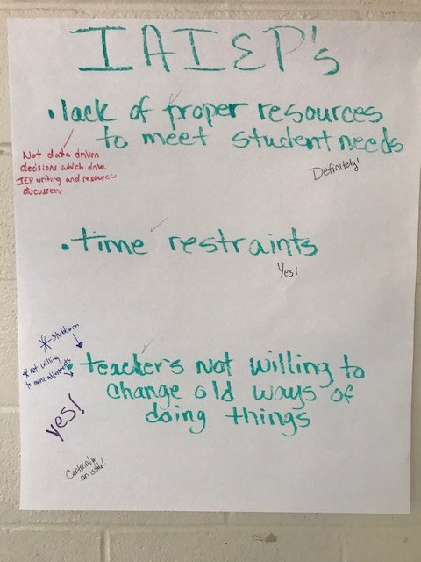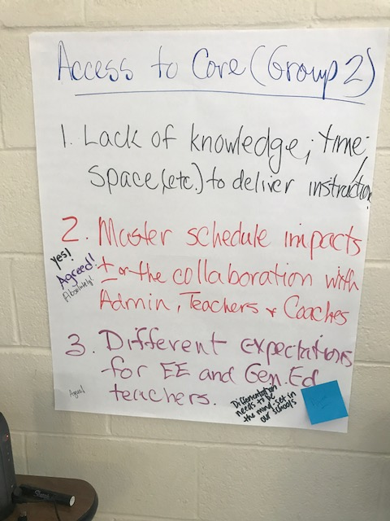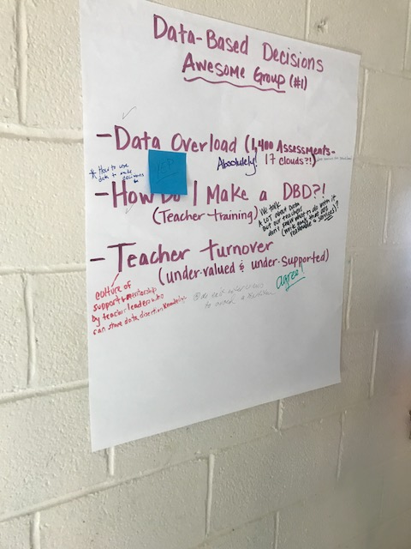

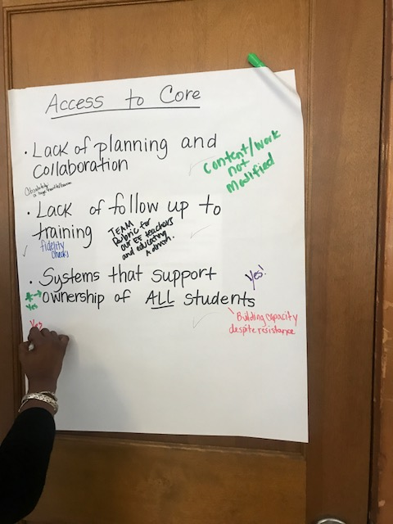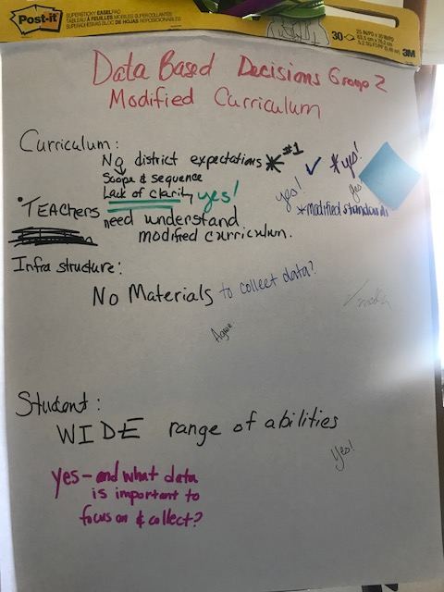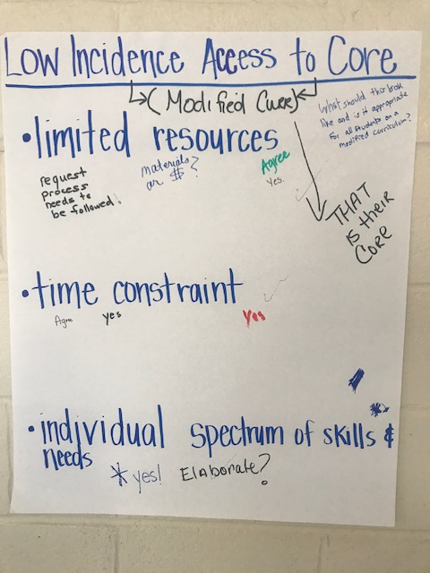

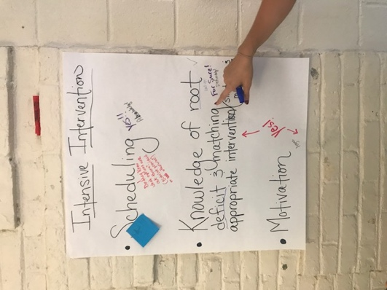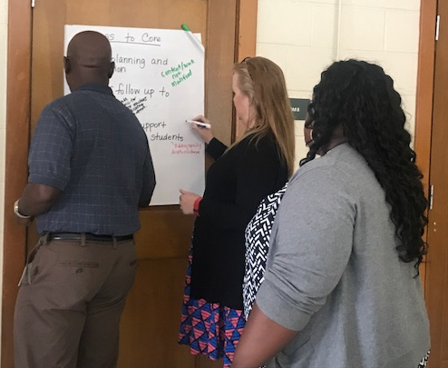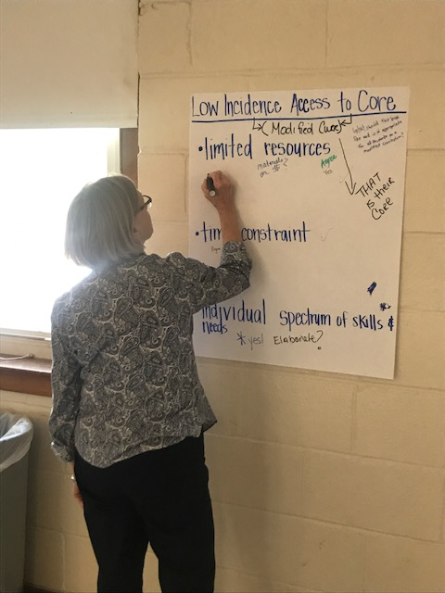

Logic Model Outcome
Based on the top barrier decided by the Spend A Buck protocol, what would be the ideal outcome if the barrier was completely removed?
- Instructionally appropriate IEPs will lead to higher quality instruction and ultimately higher student success. GROUP LEAD: Jill Purdue
- Special Education focused PD for General Educators GROUP LEAD: C. Flor
- All teacher would understand how to determine and implement effective and appropriate interventions. GROUP LEAD: Kerri Bocker
- All teachers would know how to make data-based decisions. GROUP LEAD: Charishma Price
- All MNPS low incidence teacher have access and knowledge of resources to access high quality instruction. GROUP LEAD: Alexis Sutor (Shidler)
- Successful implementation of district wide modified curriculum and scope and sequence (set of standards/expectations) GROUP LEAD: Adrienne Fehringer Cook
- Collaboration among Admin, teachers, and coaches to support student success. GROUP LEAD: Marsha Pritchard

Leading Groups Strategies
What strategies, structures, and principles did you observe me using during today’s session that you might use when leading groups?
- Gallery Walk/Chalk Talk
- Fishbone Analysis
- Timed Activities with Flexibility
- Venn Diagram
- Think-Write-Pair-Share
- Walk Around Room
- Began session by walking around and talking to people to build relationships
- Third Point

Next Steps
- Small group plan to meet to finish discussing logic model, or road map, to inform creation of PD sessions for the spring 2018.
- Use provided PD planning template to establish objectives for the Oct. 18th meeting.
- Incorporate strategies used from today’s session into the PD planning.

Reflection
Review your Inter-VENN-tion from this morning. What is your goal now?
- support teachers with more academic and data discussions
- exiting students
- fine tune curricular and content support for LI teachers
- to support my schools by building capacity with instruction and compliance
- to advocate more for best practices at IEP meetings and to use district data more when making decision for IEPs
- to understand more about developing PD and group dynamics
- work smarter not harder
- increase student outcomes by empowering teacher to make appropriate decisions about need and interventions
- to collaboratively develop and implement plans for success for our students, teacher, parents
- build something to scale
- to increase communication and collaboration with my teammates and other professionals
- to make my schools more informed about how to make data-based decisions
- support schools effectively
- build capacity for teachers and admin
- to assist schools to build capacity to positively impact student success
- to help ensure that all teachers across district have knowledge/awareness of access to low budget resources for low incidence students to access modified core curriculum
- build capacity of high school EE teachers
- to ensure that everyone on the team, who support student with disabilities, has a clear understanding of expectations and access to materials to help student show growth
- build capacity in buildings, teacher leaders and for all staff to gain confidence
- to assist teachers in becoming confidently and expertly able to provide SPED services

How was the Meeting?
+ | ∆
- good  - felt like I can make a difference  - I like the collaborative strategies  - team collaboration  - identification of root causes  - team work  - balance talking points with activities  - time to collaborate with co-workers  - interacting with my colleagues  - brainstorming ideas (problems, solutions with DBD)  - always nice to collaborate  - good information  - presented well  - good modeling  - activities  - learned new strategies for group learning facilitation  - great presentation  - excellent process to foster building capacity  - opportunity to collaborate with peers  - collaborative inquiry  - great strategies  - enjoyed learning about new books  - I enjoyed the highly collaborative component  - collaborative work  - attempt to get actionable steps in place  - fishbone—like the idea of deciding barriers and making a plan  - pacing of activities  - organized  - very knowledgeable | - time constraint  - maybe start time earlier  - stick to time frame  - coming in, I was unclear of the purpose of today  - more guidance on what needs to be included on a DBD presentation  - way too long  - talked too much  - Isn’t there someone in the district in charge of PD? Why are we developing them for them?  - did not clearly understand what the expectation was when the PD was placed on my calendar  - overwhelming  - big task  - we could have gotten more planning done  - too much frou frou  - longer PD sessions and breaks  - creating a PD is not an appropriate goal for our group. We need time to develop scope/sequence.  - clear expectations of what the purpose was today

