Today’s Outcomes:
- Provide an overview of MNPS’ Data-Informed Decision Making Ecosystem
- Model the MNPS collaborative inquiry process as an approach for developing a data-informed decision making culture.

Data-Informed Decision Making Ecosystem
Johnson, 2016; Johnson, in press

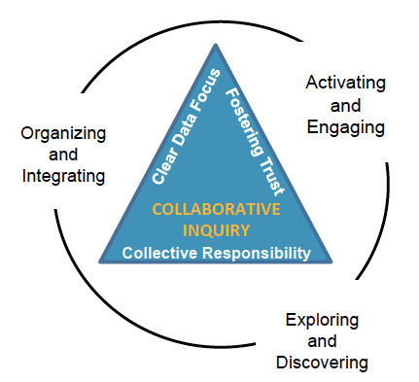
MNPS Collaborative Inquiry
Collaborative Inquiry is a data-based team process that consciously uses the collaborative learning cycle (activating and engaging, exploring and discovering, and organizing and integrating) and the qualities of effective groups (fostering a culture of trust, maintaining a clear focus, taking collective responsibility and data-informed decision-making).

Modeling the Collaborative Inquiry Process

Activating and Engaging---TOPIC: Attendance
- My name is…
- My relationship to the topic is….
- My expectations for today are…..

Exploring and Discovering—Observations
- MNPS Attendance Journey Overview
- Calibrating Activity
- MNPS Attendance Data Warehouse Dashboards for 2014 through 2017 Observations
  - attendance for males and females basically the same
  - attendance rates for various ethnic groups similar except Asian students have lower absences
  - ED and SWD students have higher absences
  - LEP students have lower absences
  - yearly attendance trends by grade levels are similar
  - overall, yearly attendance trends similar

Organizing and Integrating—Recommendations
Given the data observations, what might be some recommendations you have for improving attendance for MNPS students?
- Begin to have an early focus on chronic absence
- Investigate the reasons for students being chronically absent further
  - home connection? having to work?
- Identify siblings of older students who are chronically absent and try to intervene
- deeper dive into why seniors and freshman students have higher chronic absence rates
- establishing consistent and clear guidelines that can be communicated to families about attendance and restoration
- advocate for policy changes about attendance and funding
- investigate role of transportation issues as related to chronic absence
- investigate role of school choice as related to chronic absence
- Would a later start for high school decrease chronic absence?
- Consider providing work for students at schools
- partnerships to inform and engage families about attendance
- investigate MNPS students who are now MNPS parents to provide support
- find out what excites students who are chronically absent and pare them with adults who work in the related areas
- a program like big brothers/big sisters so if they are not being encourage at home they have someone else to show school is important

Reflection
Given what we have discussed, what might be some actions you take or ideas you implement in your organization?
- Would like a follow up on some solutions that you have put in place along with how you plan to track the success of those actions.
- How to leverage data to make our organization successful
- implement culture of collaborative inquiry throughout the organization
- involve staff at ALL levels in the learning/exploring process (collaborative inquiry)
- We could help look at spatial issues (geography) and student attendance
- cross collaboration across departments
- How to get all metro departments that work with school age children to deliver the same message?
- Our department needs to better engage with the stakeholders as far as interpreting data.
- I think we could use some collaborative inquiry processes in our office to investigate what our data is telling us.
- We may be able to share data regarding youth population in Davidson Co. The data may show barrier(s) that could help draw a more accurate picture.

