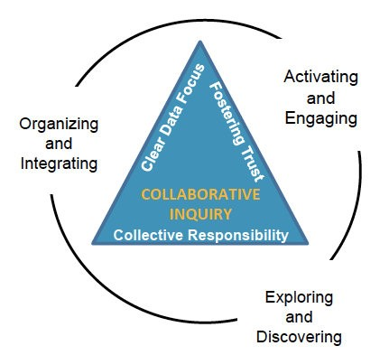
Purpose: To foster a culture of collaboration for supporting students success.

Outcome: To model the collaborative inquiry process for analyzing multiples sources of data and making informed SIP goal recommendations.

Activating and Engaging
What is your VISION for Wright Middle?
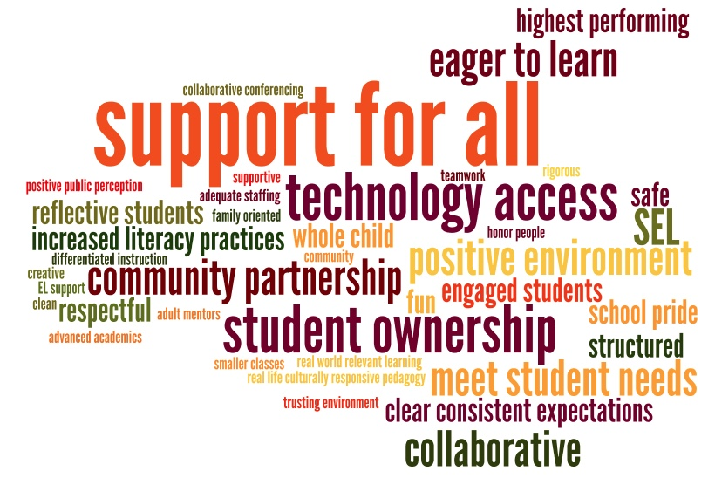

Exploring and Discovering
Data Sets from MNPS Data Warehouse
- Assessment
  - Assessment Summary (MAP Reading and Math)
  - Assessment Summary by Subgroups (MAP Reading and Math)
- Attendance—Attendance Dashboard (2015-2018)
- Behavior—Behavior Dashboards (2015-2018)

Data Observations (highlights mean multiple responses)
Assessment | Attendance | Behavior
- Lot of red—Q1 in both reading and math (3)  - Scores decreased from August to Nov. in other Quintiles (2)  - Little more decrease in reading than in math  - Q4 & Q5 % decreased from Aug to Nov for both reading and math (4)  - Increased scores in reading for W and B subgroups  - Increased scores in math for W subgroup  - Q1 % is >50% in math and close to 50% in reading (3)  - SWD Q1 over 70%  - Q1 increased from Aug to Nov in both reading and math (2)  - Q5—reading 1%; math 3%  - SWD students have higher % of Q1 on both (87% math; 77% reading)  - 5th and 6th grade have 50% of students in Q1 in Nov. | - Chronic absence % increased each year by 2-3% (5)  - Increase in perfect attendance each year  - Chronic absences consistent for males and females  - Most attendance data for Wright is less than the district avg.  - Similar % each year (2)  - Chronic abs % higher than district avg  - 5th grade had best attendance rate  - Chronic abs more at beginning and end of year  - 6th grade chronic abs is 6%  - Only 50% of students have satisfactory attendance so far this year (2)  - Most absences are unexcused  - Half of students missing 10+ days for the past 3 years  - SWD higher % of 10+ days abs (70%)  - LEP lower % of 10+ days abs (40%)  - Satisfactory attendance decrease each year  - 50 8th grade students are chronically abs. | - No. of OSS decreased from previous years  - No. of ISS decreased from previous years  - 15/16—disparity between enrollment ethnicity and incidents for B  - 17/18  - 23% B enroll vs. 37% incidents (2)  - 55% H enroll vs. 44% incidents  - Higher % of H with incidents the last 2 years  - % female incidents decreased  - Incidents increasing for 17/18 if we continue this trend  - No zero tolerance incidents  - 15/16 to 16/17—increase in incidents  - 17/18—150 incidents for 5th grade  - % of disparity had decreased since 15/16  - 5th/6th grade similar behavior incidents  - Increase in incidents from 15/16 to 16/17  - Seems to be similar again this year  - Zero tolerance decrease this year  - Increase in restorative conferences  - Almost at full year # of incidents in 17/18 at half year  - 6th—186 (17/18)---192 (16/17)  - 5th ---458 (16/17)  - In past, 100 level incidents were recorded, but not this year.  - More students with 1-2 OSS than 3+ OSS  - Increase in % of male incidents than females  - Violation of school rules is highest violation, which is a lower level violation  - 8th grade—  - 241 incidents (15/16)  - 508 incidents (16/17)  - 141 incidents (half 17/18)  - Overall OSS days % for Wright below tire % and above district %

Organizing and Integrating

2018-2019 SIP Recommendations

Goal 1—Graduation Rate
- Develop and implement process for transitioning students to 5th and 9th grades.
- Resources in multiple languages
- Teacher training—culturally relevant & competent pedagogy
- Intentional motivation in regards to college/career goals—communicate vocational relevance
- Make school a priority, lower absences
- Parental involvement
- Career/college fair planning 2-3 times per year to prepare
- Incorporate attendance incentives into PBIS
- Increase motivation for students to stay involved in academics by providing college & career ready courses/opportunities; by involving counselors & community partners to provide counseling sessions & similar opportunities for students

Goal 2—Numeracy
- Smaller classes
- Start MTSS earlier in the year
- Communication with teachers
- Achieve growth rate by MNPS
- Incorporate real life experiences
- Increase math fluency—rTII & pull out classes
- Fluency in basic facts by end of 5th grade
- Technology
- Involve community resources to provide relevant real world math situations

Goal 3—Literacy
- Smaller classes
- Start MTSS earlier in the year
- Communication with teachers
- LIT time to daily instead of Fridays
- Separate reading and ELA classes that are grouped properly to focus on lacking reading skills without losing writing, grammar, etc
- Summer reading outreach
- Improve technology—programs & hardware
- Promote books written in other languages
- Increase independent reading, in class and at home
- Technology (kindles, e-books, etc.)
- Continue with PD based on data from our literacy action plan

Goal 4—Achievement Gap
- Increase attendance rate by 10% by putting a plan in place to reach out to those students who are chronically absent
- Start MTSS earlier in the year
- Communication with teachers
- Technology for intervention and classroom use
- Summer programming to continue learning
- Improve RTII
- Improve technology
- Increase achievement for students with disabilities to align with the achievement of the “all” subgroup
- Students will have before and after school tutoring available
- Provide time and focused groups to catch up that does not make them miss other instruction
- Overtesting students

Goal 5—Culture and Climate
- 100% of students will participate in some type of activity, club, or extracurricular activity
- Clubs and sports
- High expectations—concrete rules, expectations, rewards, and consequences. School structure and management
- Clearly defined action steps for student behavior and consistent consequences
- Respectful and safe environment for students and teachers
- Re-implement student clubs
- Implement a master schedule that meets the needs of both intervention and honor students
- Appreciation of faculty
- Involve community members
- Parent investment
- Decrease our chronic absenteeism by setting up counseling groups to monitor and support
- Decrease class size in order to improve teacher/student relationships and differentiation practices
- All represented cultures in our school will be showcased in an International Day Festival
- Parent involvement/mentors
- Students will participate in structured collaborative conferencing to discuss concerns: personal or academic that they have
- Provide after school activities and clubs
- Increase community involvement
- Increase personalized, goal setting and accountability practices
- Protected SEL time
- Clubs & teams
- More translators—more languages
- Invest in teachers—collaborative time, paid time
- Care team—staff dedicated only to restorative practices, home visits, care calls, safe space
- Provide opportunities for staff learning of strategies to implement SEL in classroom

Exit Ticket Reflection
What actions might I take as a result of today’s meeting?

- We need (as a faculty) to have a day/meeting on coming up with broad strokes/out of the box strategies to improve this school NOT put it off until next year. This means discussions and debates.
- Work on school structure and climate
- Need to get students involved
- Need to get our attendance % better
- Increase math and literacy assessments
- Have follow up conversations with students that are chronically absent
- SIP goals—can’t stand alone
- Clearly defined culture and goals
- Continue to provide a safe supportive environment where students can learn
- We need to have better communication
- We need to work on a consistent behavior plan schoolwide
- The school data was pretty insightful considering I will be entering my first year as a teacher in the fall
- Offer resources when possible
- Spend time setting goals with students to help them take ownership of learning
- Spend time filling in gaps no just passing a student on
- Data dive with team with purpose
- Make more use of data provided
- Have open discussions based on data about needs of our school for next year
- Thinking of summer professional development
- 5 year career planning
- The visions seem to be the same all around
- Parents need to be held more accountable for their children’s grades and behavior
- Student ownership
- United teamwork
- Disappointing data (not growing)
- Don’t spend money on programs or cancel subscriptions without teacher input
- iReady should be all access in building
- seeking grants for improved technology
- increased attention to how I treat/think about my black and African American students
- help as many students as possible to improve behavior
- better differentiated instruction
- iReady to target students’ deficits and increased skills
- Use ANET to increase rigor
- Use independent reading to increase engagement and achievement
- Work on master schedule that supports learning
- Try to understand how really this data is realistic
- Look into data warehouse
- Focus on student engagement in my classroom
- Find short articles or paragraphs on math for students to work with and read
- Consistent expectations
- Support scientific identities for all
- 7th grade “care team” to engage with students we are concerned about
- To support cognitive growth and confidence
- More SEL time in my personal classroom
- To support positive developing identities and relationships
- I will be more thoughtful and intentional for how I provide support for my students with disabilities
- Implement art/expression into activities
- Improve communication in regards to educational relevance to their lives
- When students are absent frequently, asking them why do they feel missed?
- Consider my role in improving student attendance
- Consider how to better engage students
- Create resources for students
- Take time for each class for SEL
- Translate
- Many doable actions were discussed that we can do:
  - Transitions to 5th & 9th
  - Monitoring of absences
  - Master schedule created
- Add SEL resources to online teacher toolbox
- Consider my role in the school and how I might be help achieve our vision
- Increase my use of grade level literacy/vocabulary and technology in classes

How was the Meeting? FeedForward
+ | Δ
- Looking at relevant data (5)  - Collaborating with teachers (7)  - Informative (2)  - Good insight; eye-opening (4)  - Too the point  - Working in groups to analyze data  - Review of school data  - Used time with purpose  - Group work  - Fast paced—well paced (3)  - Purposeful  - Having a chance to voice our concerns and ideas  - Great meeting  - Positive attitudes  - Like just making observations not trot to assume about data (2)  - Good team cooperation  - Covered many topics in a relatively short time  - Opportunity to discuss data and recommend action steps  - The talks gave us a lot to think about for next year.  - Listening to one another  - Good discussion on what needs to be done  - Good helping summarize a lot of diverse thinking  - Great job getting contributions from the team  - Collaborative inquiry process (4)  - Well-facilitated (2)  - Open discussion without whining (2)  - Good observations from team  - Good ideas—we know what we need  - Time  - Effort  - Reflection time  - Space for us to share without judgement  - Acknowledgment of all ideas  - Good to be heard  - Concise  - Engaged group of people  - Good use of time  - Loved the side by side lists on the board | - More time (11)  - Not announced  - Need meeting agenda  - Follow-up  - Set up in groups throughout school  - Continue to work on behavior expectations  - Post-it style was a bit repetitive  - You should come back soon  - Without (support) parent input, it will be hard to change discipline.  - Change culture of need for education  - We are failing but trying so hard  - Obscure data labels (just put the word)  - Show all data with equal amount of time or months  - Increase technology  - More/varied assessment data  - Add “I wonder”  - Still didn’t answer how we are going to do them all  - Just talk and let me work  - We are smart. Just let us send ideas.  - Too much at once—only focus on a few things  - Whole discussion  - Where do our suggestions go?  - Where does error/practices come into account with the data?  - Whole group discussion on suggestions  - Allow us to use computer to find data in data warehouse—could use the practice  - Jargon—I forget what it means  - Time to respond in writing  - After listing goals, then observations, compare the perceptions.

