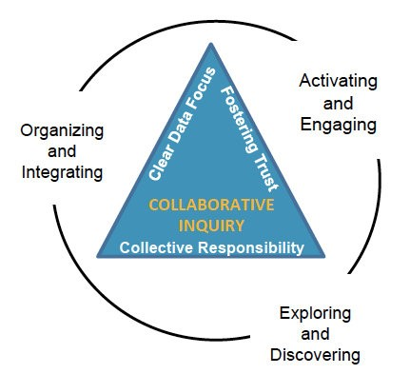
Learning Technology Core Team Meeting Minutes
January 4, 2018

Activating and Engaging---Accomplishments

Exploring and Discovering--Data Observations
Data Source | Observations
90 Day Planner | - empower others  - learn from others  - attend PD  - keep current  - visible by all  - supporting others  - district tech plan  - improve student learning  - streamlining and increase efficiency  - collaboration and communication
Planner Data | - 234 responses  - Most service 1-1
Bright Bytes | Classroom Use of 4 C’s | - 75% of teachers report can solve own problem  - 82% believe tech part of daily live  - 41% (’17) and 43% (’16) use multimedia  - 23% (’17) and 22% (’16) digital citizenship
 | 21st Century Report | - 65% use assistive tech  - 23% students write online  - 75% spend less than 3 hrs teaching digital citizenship
 | Admin Report  (Teachers report about their respective admin.) | - 37% teachers feel recognized for using tech  - 40% teachers report tech is topic at their school  - 47% report tech as part of classroom observation  - 20% report internet filter gets in the way of teaching
 | SAMR Report | Year | S | A | M | R
 |  | 2016 | 27% | 16% | 4% | 6%
 |  | 2017 | 30% | 16% | 2% | 4%
Margie emailed copy of District KPI’s to Dr. Brinson.

Organizing and Integrating—Team Objectives for Spring 2018
- Provide professional learning
- Build our capacity
- Develop and streamline services based on data

Next Steps:
- Margie will type up minutes
- Team continue to work on fleshing out the plan and revisit it in 2 weeks
- Jeremy redo the document

Exit Ticket Reflections:
What actions might you take as a result of our meeting?
- deeper dive into BrightBytes data
- try to focus on and find learning opportunities
- looking at data 1st, then creating goals
- requiring feedback for myself
- follow up on learning plan
- rethink tools for streamline
- complete 3 goals

Meeting Feedback
How was the meeting?
+ | ∆
- diving into the data and doing (2)  - looking at various data sources  - time to collaboration  - having us to look at district initiatives  - time to learn the collaborative inquiry practice  - thinking as a team | - some awesome examples of groups doing this work  - more time to dive deep into the data (3)  - timing and pacing  - no real timekeeper thought/reflection  - could have used more time to draw connections between data and actions

