- Welcome, Norms, Purpose, Objectives---Dr. Michelle Springer
- Community Builder—Norman Merrifield
- Inter-VENN-tion---Margie Johnson
  - Fears:

    - avoiding burn out
    - sustainability of the work
    - loss of great people and talent
    - things beyond our control, which cause frustration
    - spending too much time on the problem and not the solution (“analysis paralysis”)
    - not moving fast enough & children being left behind
    - lack of relevancy
    - misalignment of practice and momentum
    - loss of traction
    - too much testing
    - not enough time
    - not losing a sense of urgency
    - common expectations being misaligned for parents & schools
    - not enough academic rigor

  - Hopes

    - perseverance
    - tenacity
    - realize importance
    - ownership
    - motivation to access
    - engagement
    - active stakeholder voice—needs assessment
    - meet students where they are at
    - collective impact—ALL
    - confidence—self-efficacy
    - skyrocketing achievement
    - inspiring
    - access to technology
    - life long readers and writers
    - impactful

  - Celebrating Successes

    - sense of momentum
    - culture of literacy
    - resource availability
    - light bulb moments (right book, strategy, engagement)
    - relevancy
    - student excitement about literacy
    - student voice/choice
    - productive, richer, deeper conversations—debate
    - build teacher capacity for cross-curricular literacy
    - school-based capacity building for support and resources
    - collaborative planning—cross subject areas
    - sharing knowledge and strategies—communication of ideas
    - integrating restorative practices to develop safe learning environments
    - developing independent learning strategies & ownership of learning

- How do we spread these successes throughout all MNPS classrooms?
  - What Works in Education: The Politics of Collaborative Expertise—John Hattie, Fall 2015
    - Shift the Narrative….
      - “from ‘fixing’ the teacher to collaborative expertise”
- Fishbone Analysis (Stephanie Adams, Margie Johnson, Dr. Michelle Springer)
  - Overview of Fishbone Analysis
  - Divided into 3 groups to discuss root causes through the lenses of classroom, school, and district.
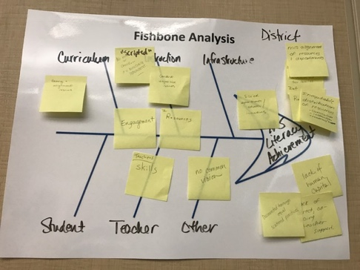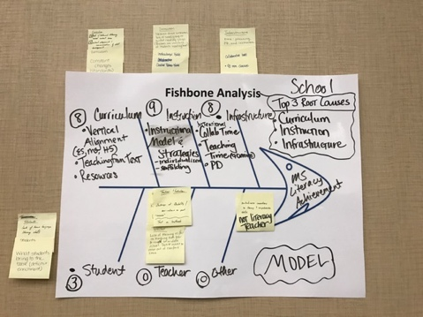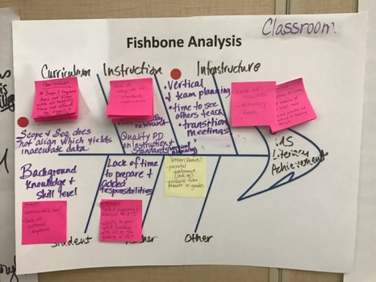

Top 3:
- Lack of alignment throughout curriculum and with assessments
- Lack of differentiated, student-focused instructional strategies and resources
- Lack of differentiated system of support for educators

Lunch provided by Montage Education.

- Aha Moments
  - What is an aha point or personal connection you are making from the session?

    - Focus so it’s “not one more thing” but becomes habits of practice
    - need to get it right
    - meet student needs and challenge them
    - systems approach
    - alignment about root causes
    - tiered approach helped with alignment
    - relevant
    - ownership
    - consistent message
    - celebrating successes and leveraging them

- Logic Models (Appendix for ROUGH DRAFTS)
  - Overview of logic models and components
  - Divided into 3 groups based on the top 3 root causes identified during the fishbone analysis.
    - Brainstormed possible ideal, long term outcomes
    - Reached consensus of no more than 5 long term outcomes
    - Backwards mapping for identifying short and intermediate outcomes and listing activities.
- Next Steps
  - Continue work as a network to address root causes and remove the barriers
    - unpacking standards in a collaborative environment with attention to aligning to assessment
    - collaboration to revise Scope and Sequence & to add resource alignment
    - development of an interactive, user-friendly library of digital resources
  - Collaboration between literacy teachers and content areas
  - Compile logic models and schedule another meeting for feedback and next steps
  - Continue fostering a safe culture to support risk taking and innovation
  - Compile information about CoP work, including a contact list with identified strengths
  - Communicate with principals about work
  - Use PD days to observe other classrooms
  - Identify a communication mechanism for the network
  - “Walk the walk”---exhibit positive energy and synergy
- Exit Ticket Reflection
  - Reviewing your Inter-VENN-tion goal from this morning, what is your goal now for supporting literacy?
    - Create a library of resources—meeting needs of cultural and life relevancy.
    - My goal is to help my students, other teachers, my school, and district to help increase the level of literacy in our students.
    - Become a more effective leader in literacy—recognize ways I can support teachers more effectively
    - Resources for teachers in 1 central location
    - My goal is to inspire teachers in my school to teach students how to read by using strategies that are research-based and meet the needs of each student.
    - To assist teachers to help students to recognize the importance of reading.
    - To help MNPS to improve educational equity among clusters by establishing/maintaining norms that allow students to access/retain information
    - understand the standards enough to create effective assessment
    - My goal is to continue to be a positive resource/advocate for literacy for my school and my district. I want to continue to learn so that I can support the literacy movement.
    - Identify a few things and plan (deep) to impact change
    - I will continue to research and provide resources for ELA teachers, but more importantly encourage teachers to innovate and collaborate in intentional meaningful ways.
    - Create pushing my teacher to try new things and hold students to high expectations with high models/supports
    - Working to provide the best quality instruction for my students
    - My goal for supporting literacy is to be present in this process
    - Work with the 7th and 8th grade ELA teachers to map out how best to immediately bring change to our students competency in literacy
    - Empower teachers by devoting more time being in classrooms in order to support literacy development
    - Understand needs at all tiers to design programs for parents to support literacy
    - To develop a community of educators that empower students with student-owned strategies
    - Now, my goal is to implement effective practices (common assessments, vertical planning, cross-cluster planning with other teachers) to enhance literacy across the board.
    - My learning goal is to support the work of group with my knowledge of assessments and data.
    - Begin developing alignment at our school related to curriculum, assessment, and instruction that supports ALL culturally and linguistically diverse students.
    - To help create a culture of literacy within my school
    - Be very clear and explicit in PD, connecting strategies to literacy targets from the district.
    - My goal is to give my students a voice in the text subjects we sue to make it relevant to their lives.

- Meeting Feedback
Plus | ∆
- I loved the inspirational, vision-driven, and specific conversation about how to overcome barriers.  - time to collaborate  - wonderful PD session….thank you  - great workshop  - great structure for getting better results  - loved the collaborative discussion in a safe community. I felt we were geared toward positivity and growth.  - wonderful collaboration  - amazing ideas shared  - great, very informative  - agenda & timing  - collaboration  - diversity of group  - group work/talk time  - great collaboration (2)  - great resources shared  - dialogue and engagement  - excellent cross-section of teachers, admin in district, and building team of committed people for the literacy of our kids  - great collaborative discussions  - thinking time  - level of collaboration  - people at meeting focused on literacy  - good discussions  - feel the energy  - helped me to think deeper about MS literacy achievement  - tackling the big issues  - inviting diverse stakeholders  - effective discussions about how to implement literacy | - more time (8)  - I wished we had done intros with the group.  - lack of context—ideas were all over  - not enough emphasis on network as opposed to “my class”  - missed opportunity for video of the collaborative work  - define the ultimate goal for the group  - “CoP”—“What, what”  - need to continue  - more protocols to facilitate discussion  - I wish more teachers, admin, & community leaders could’ve been here.

Logic Model Teams
Curriculum | Instruction | System of Support
Brooke Denton  Johneth Mooreland  Michelle Prater  Tavia Beasley  Shana Ward  Debbie Mitchell  Canidra Henderson  Larry Miles | Trellaney Lane  Nicole Fedele  Natalie Williams  Chelsey Butnum  Robynn Lemon  Shannon Fey  Marcus Kinnon  Michelle Henderson  Rommie Vasser | Sonya Mansfield  Neal McDonald  Anthony Lutz  Courtney Rayburn  Alison McArthur  Emily Munn  Renee Thessing  Rachel Roseberry

Planning | Evaluation
Tavia Beasley Stephanie Adams  Debbie Mitchell Margie Johnson  Trellaney Lane  Michelle Springer | Tamika Tasby Johnetta Mooreland  Neal McDonald Michelle Springer  Kisha Cox Margie Johnson  Larry Miles

