What are some strategies, structures, and principles you observed?
Strategies | Structures | Principles
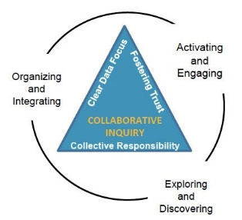
Margie Johnson
margie.johnson@mnps.org
www.mnpscollaboration.org

