Activating and Engaging

Looking Back…..Looking Forward
Past | Now | Future
- play  - community based  - rare  - socialization  - no accountability  - inconsistent  - lack of research  - grassroots, mainly run by moms | - play-based  - accountability  - some collaboration (collab on projects, but not on daily work)  - higher expectations/standards  - professionals  - well-educated staff  - PD opportunities  - common curriculum  - developmentally appropriate practices  - differentiated activities  - variance in best practices  - departmental/siloed | - deeper level of understanding for all (continuum)  - improved practice  - more collaboration  - child-centered  - co-teaching  - better understanding and use of data  - effective PLCs  - consistency in practice  - sustainability with resources within schools  - authentic family involvement  - research-based practices  - positive culture (welcoming/joy)  - increased compensation

Exploring and Discovering

Data Observations
BIG ROCKS
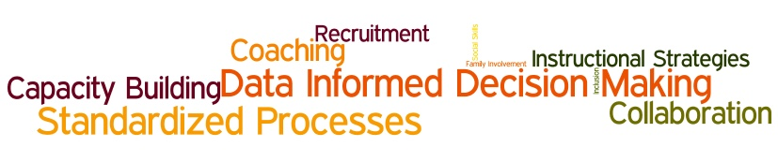

PRI
Demographics | - stable demographics for males and females  - 10% increase in ELs in expansion than enhancement  - increase no. of white students in 16-17  - expansion has 16% more males  - 46% of students in expansion speak a language other than English
Literacy | - Expansion had 10 pt more growth in PPVT and Letter Word  - ELC didn’t have as high of gains as others  - spelling lowest of all types
Math | - similar growth for all  - lowest area was quantitative concepts  - students at ELC enter with higher scores than PDG exits  - ELC has less gains  - ELC spring scores met average
Self-Regulation | - similar growth between Expansion and Enhancement  - MNPS & ELC leaving at about the same  - ELC students enter with slightly higher scores  - Expansion students enter with lower scores
Classroom Activities | - variance high among activities  - whole group time avg between Expansion and Enhancement consistent (70 & 71)  - more small group in expansion than enhancement  - less transition time in expansion than enhancement  - half time is spent in non-instructional activities (all)  - growth in focus areas from 15-16 to 16-17
Levels of Instruction | - most instruction at basic to low level
Engagement | - centers has higher engagement  - higher engagement in Enhancement at centers  - higher engagement in expansion at small group
Teacher Behaviors | - 2% increase in physical handling  - decrease in yelling/cursing  - decrease in behavior disapproval  - higher rate of disapproval vs. approval
Outlying Questions | - What is average growth in literacy? math?  - If ELC closer to norm, should growth be less?  - What is the expectation of self-regulation data?

High Quality Start for All (attached)
MNPS Strategic Plan (attached)

SMART Goals (attached)
Dividing into three groups.
Culture | Lori (lead), Cheryl, Mariana, Tracy
Instruction | Rhiannon (lead), Holly, Dana
Student Support | Phyllis (lead), Mariechelle, Cameshia, Arthur, Pat

Next Steps
- Margie compile minutes and research SMART goals articles
- Margie email groups asking for SMART goals to be submitted by Wed., Sept. 20
- Leads coordinate with Margie for follow-up meeting to finalize SMART goals and
- FINAL DEADLINE: Oct 6

Exit Ticket Reflection
- Aligning of how people see the data and use the data—researchable
- developing of SMART goals
- focus on direction of department
- data talks need to be more than emails. I’m excited to brush up on smart goals and adjust my work plans
- check in with Tina about norms vs. standard score
- I will go back and take another individual look at data
- work to coordinate my team to get SMART goals together
- work to identify department needs and research/develop SMART goals for instruction
- focus PD on growing skills/abilities that will make a difference
- really take a look at goals via “SMART” method
- when looking at data, look at facts before making assumptions
- focus on climatein CLASS to impact culture
- I will purchase Groups at Work and Leading Groups books
- I will reevaluate my first PLC with professional input and redeliver it.
- complete the SOW/work plan by Oct 6

Meeting Feedback—How was the Meeting?
+ | ∆
- team building  - common lens  - reflection on data  - inferences  - excellent facilitation  - great humor  - appreciate the way you push back when needed  - I thought you did a great job engaging  - liked the collaboration and discussion  - very knowledgeable of content and process of collaboration  - focused our thoughts and purpose  - great facilitation  - great method to keep us on track  - great way to break down collaboration inquiry into digestible format | - more time  - I can’t really think of anything  - needed a little more time on goals, but we took up some of your time  - examples of SMART goals  - more time for that much data  - more SMART info  - probably needed an additional 30 min

